**LAB 8  
Creating a VPC in Terraform**

**STEP 1: Create a new Directory.**



**STEP 2: Create terraform configuration file (main.tf)**

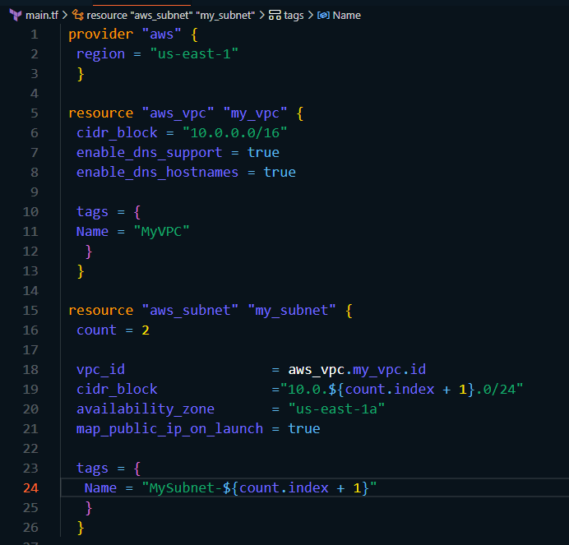

**STEP 3: Initialize and apply.**

* **terraform init**

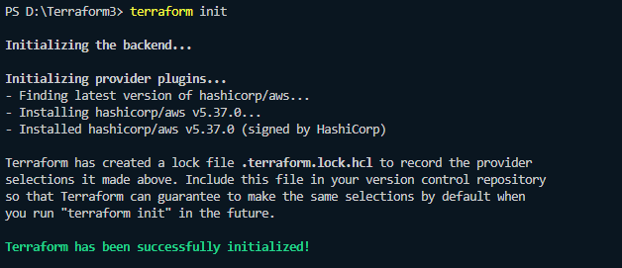

* **terraform apply**

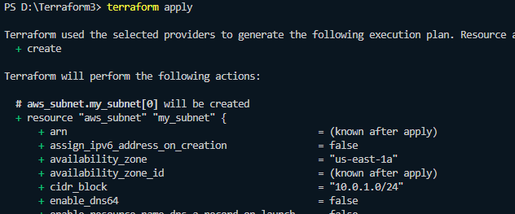

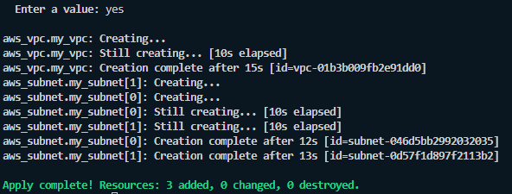

**STEP 4: Verify resources in AWS console.**

* Log in to the AWS Management Console and navigate to the VPC service.
* Verify that the VPC and subnets with the specified names and settings have been created.

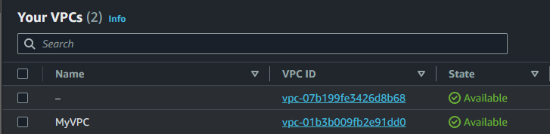

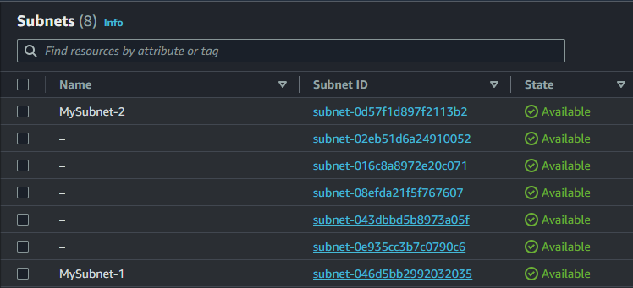

**STEP 5: Clean up.**

* After testing, we clean up the used resources by terraform destroy.

